

Data Structures

Experiment (1)

SID： | 242910701126
Name： | TASKIN AHMAD AL FARUQE

《Data Structures》
Title： | Student score management system.
Experimental Environment：
C++
Experimental Content：

1. Concept
A Sequential List is a linear data structure that stores elements in a continuous memory space using an array.
Each element can be accessed directly by index, which makes searching by position efficient.
In this experiment, a sequential list is used to store student score information, including:
- StudentID
- Name
- Sex
- Chinese score
- Math score
- English score
- Total score
The system supports:
- Creating a linear list
- Finding the length of the list
- Outputting the list
- Inserting a student at a specified position
- Searching a student by StudentID
- Getting student information by position
- Deleting a student at a specified position

2.Code(with Comments)

#include <iostream>
#include <string>
using namespace std;

#define MAXSIZE 100

// Student information
typedef struct {
int id;
string name;
string sex;
int chinese;
int math;
int english;
int total;
} Student;

// Sequential list structure
typedef struct {
Student data[MAXSIZE];
int length;
} SeqList;

// 1. Create a linear list
void InitList(SeqList &L) {
L.length = 0;
}

// 2. Get the length of the list
int ListLength(SeqList L) {
return L.length;
}

// 3. Output the linear list
void PrintList(SeqList L) {
if (L.length == 0) {
cout << "List is empty." << endl;
return;
}

cout << "ID\tName\tSex\tChinese\tMath\tEnglish\tTotal\n";
for (int i = 0; i < L.length; i++) {
cout << L.data[i].id << "\t"
<< L.data[i].name << "\t"
<< L.data[i].sex << "\t"
<< L.data[i].chinese << "\t"
<< L.data[i].math << "\t"
<< L.data[i].english << "\t"
<< L.data[i].total << endl;
}
}

// 4. Insert element at specified position
bool InsertList(SeqList &L, int pos, Student s) {
if (pos < 1 || pos > L.length + 1 || L.length >= MAXSIZE)
return false;

for (int i = L.length; i >= pos; i--) {
L.data[i] = L.data[i - 1];
}

s.total = s.chinese + s.math + s.english;
L.data[pos - 1] = s;
L.length++;
return true;
}

// 5. Find student by StudentID
int LocateElem(SeqList L, int id) {
for (int i = 0; i < L.length; i++) {
if (L.data[i].id == id)
return i + 1;
}
return -1;
}

// 6. Get element by position
bool GetElem(SeqList L, int pos, Student &s) {
if (pos < 1 || pos > L.length)
return false;

s = L.data[pos - 1];
return true;
}

// 7. Delete element at specified position
bool DeleteList(SeqList &L, int pos) {
if (pos < 1 || pos > L.length)
return false;

for (int i = pos - 1; i < L.length - 1; i++) {
L.data[i] = L.data[i + 1];
}

L.length--;
return true;
}

// Main function
int main() {
SeqList L;
InitList(L);

Student s1 = {1001, "Tom", "M", 80, 85, 90};
Student s2 = {1002, "Lucy", "F", 90, 92, 88};
Student s3 = {1003, "Jack", "M", 78, 75, 80};

InsertList(L, 1, s1);
InsertList(L, 2, s2);
InsertList(L, 3, s3);

cout << "Student List:\n";
PrintList(L);

cout << "\nList Length: " << ListLength(L) << endl;

int pos = LocateElem(L, 1002);
cout << "Student ID 1002 position: " << pos << endl;

Student temp;
GetElem(L, 2, temp);
cout << "Student at position 2: " << temp.name << endl;

DeleteList(L, 1);
cout << "\nAfter deleting first student:\n";
PrintList(L);

return 0;
}

Running Result：

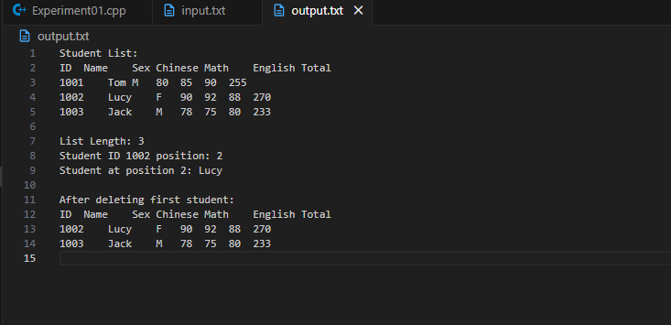
Encountered Problems：
• Elements must be shifted when inserting or deleting.
• Position range checking is necessary to avoid overflow.

Solutions：
• Use for-loops to shift elements.
• Strictly check position validity.
• Calculate total score automatically during insertion.

